Name: Manish Kumar

Admission Number: 20SCSE1010830

Section 10 Group P1

**Experiment 2**

**Aim**: To understand the use of arithmetic operation, variable declaration and data types in python using jupyter notebook (Anaconda).

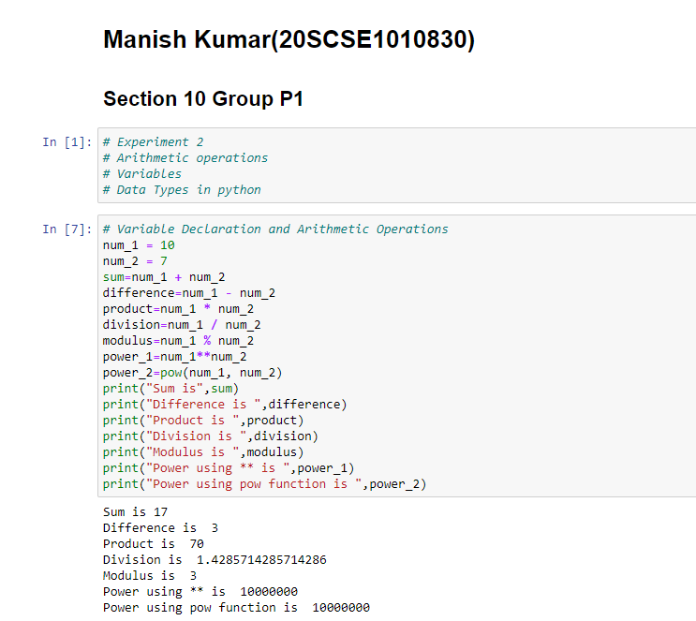

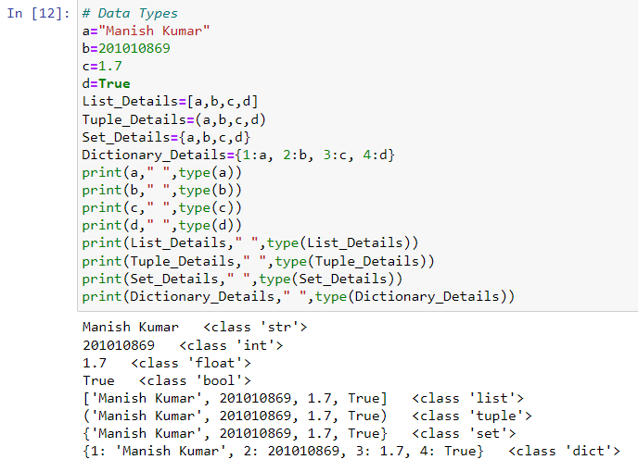

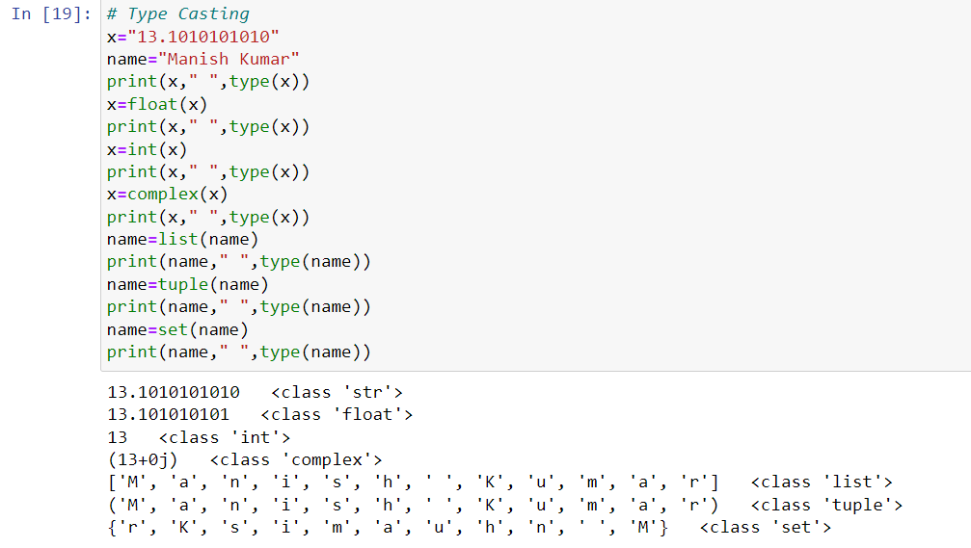

**Conclusion:** Successfully executed the arithmetic operation, variable declaration and data types concept on jupyter platform.